Purpose of Kubernetes is to host the application in the form of containers in an automated fashion so that we can easy deploy as many instances of the application as required and easily enable communication between different service within the application

Etcd default port : 2379

All component manifest will be under

/etc/kubernetes/manifests/

Eg: /etc/kubernetes/manifests/kube-scheduler.yml

Note: kubeadm does not deploy kubelets.

We should manually install on worker node using the command

wget https://.....

**Create an NGINX Pod**

kubectl run nginx --image=nginx

**Generate POD Manifest YAML file (-o yaml). Don't create it(--dry-run)**

kubectl run nginx --image=nginx --dry-run=client -o yaml

**Create a deployment**

kubectl create deployment --image=nginx nginx

**Generate Deployment YAML file (-o yaml). Don't create it(--dry-run)**

kubectl create deployment --image=nginx nginx --dry-run=client -o yaml

**Generate Deployment YAML file (-o yaml). Don't create it(--dry-run) with 4 Replicas (--replicas=4)**

kubectl create deployment --image=nginx nginx --dry-run=client -o yaml > nginx-deployment.yaml

**Namespace:**

* We can also assign quota of Resources to each of the namespaces that way each namespaces is guaranted certain amount and doesn't use more than its allowed limit

Example to connect to db from different namespace,

mysql.connect("db-service.dev.svc.cluster.local")

cluster.local = Default domain name of kubernetes cluster

svc = Sub domain of the service

dev = Namespace

db-service = Service Name

To list pod on default namespace

> kubectl get pods

To list pods on other namespace

> kubectl get pods --namespace=kubesystem

To create the pod on default

* Kubectl create -f pod-defination.yml

To create the pod on particular namespace

> kubectl create -f pod-definition.yml --namespace=dev

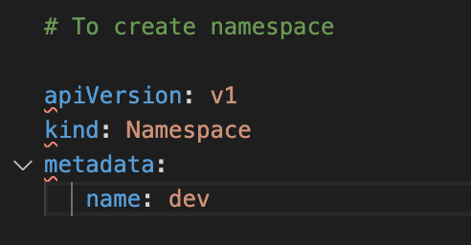

**> kubectl create -f namespace-dev.yml**

another way:

**> kubectl create namespace dev**

**Switch to other(dev) namespace permanently**

**> kubectl config set-context $(kubectl config current context) --namespace=dev**

**To view pods in all namespaces,**

**> kubectl get pods --all-namespaces**

**To Limit Resource in a namespace, create a Resource Quota**

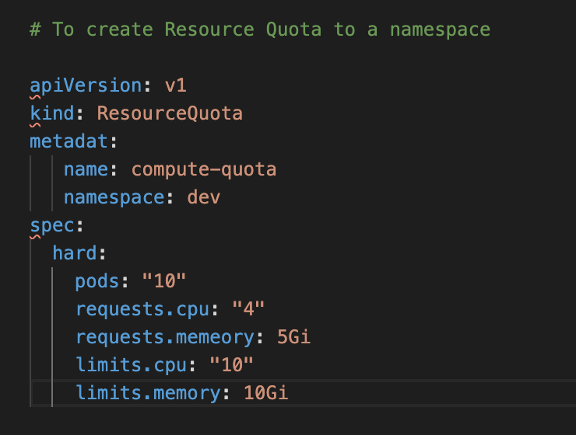

**> kubectl create -f compute-quota.yaml**

**Node Affinity:**

**The purpose of Node affinity to ensure that pod is created on the respective node**

**Node affinity Type:**

**requiredDuringSchedulingIgnoredDuringExecution**

**PreferredDuringSchedulingIgnoredDuringExecution**

**Resource Requrements and Limits**

**By default kubernetes sets**

**1 vCPU and 512 Mi memory**

**Limits and requests are set on the each container with in the pod**

**If pd exceed the memory limit then the pod will be terminated**

In the previous lecture, I said - "When a pod is created the containers are assigned a default CPU request of .5 and memory of 256Mi". For the POD to pick up those defaults you must have first set those as default values for request and limit by creating a LimitRange in that namespace.

1. apiVersion: v1
2. kind: LimitRange
3. metadata:
4. name: mem-limit-range
5. spec:
6. limits:
7. - default:
8. memory: 512Mi
9. defaultRequest:
10. memory: 256Mi
11. type: Container

**Daemon Sets**

**Daemon sets are like replication set it helps us to deploy multiple instances of pods but it runs one copy of the pod on each node in the cluster.**

**Whenever the new node is added to the cluster a replica of the pod is automatically added to that node when the node is removed pod is automatically removed.**

**The Daemon Sets ensures that one copy of the pod is always present in all nodes in the cluster.**

**Kubeproxy can be deployed as deamon sets.**

**Kubectl create -f daemonset.yaml**

**Multiple Scheduler:**

**Monitor Cluster component:**

Kubernetes doesn’t come with the full feature monitoring solution however there are other source.

Metric Server: We can have once matirx server per kubernetes cluster.

Metrics server retrieves metrix from each of the kubernetes nodes and pods aggregates them and stores them in memory

It is an in-memory montioring solution and doesn't store the matrics on disk as a result we can't see historical performance data.

Kubelet contains a subcomponent called as "cAdvisor or container Advisor" . It is responsible for retriving performane metrics from pods and exposing them through the kublet api to make the metrics available for the metrics Server.

* kubectl top node
* kubectl top pod

**Logs - Kubernetes is with event -simulator image**

**Rolling Updates and Rollbacks**

**Rollout and Versioning in a deployment:**

* When we first create a deployment it triggers a rollout, a new rollout create a new deployment Revision
* Eg: Revision1
* In the future when the application is upgraded meaning when the container version is updated to the new one , a new roll out is triggered and a new deployment revision is created named Revision2
* This helps us to keep track of the changes made to our deployment and enable us to rollbacks to the previous version of deployment if necessary

To See the status of rollout:

* Kubectl rollout status deployment/myapp-deployment

To see the revisions asnd history of rollout:

* Kubectl rollout history deployment/myapp-deployment

Deployment Strategy:

* Recreate
* Rollingupdate

**. Rollingupdate is the default deployment strategy**

**Rollback:**

* **Kubectl rollout undo deployment/myapp-deployment**

**Commands and arguments:**

**Docker file: Kubernetes**

**ENTRYPOINT overrides command:["sleep2.0"]**

**CMD ["5'] overrides args: ["10']**

**ENV variable in kubernetes**

Set an env property. Env is an array

**Configuring configmaps in application**

* **Configmaps are used to pass configuration data in the form of key value pairs in kubernetes.**
* **When the pod is created inject the configmap into the pod so that key value pair are available as env variables for the application hosted inside the container in the pod**
* **There are 2 phase invlove. First create the config map and second inject them into the pod**
* **Kubectl create configmap <config-name> --from-literal=<key>=<value>**

**Eg: kubectl create configmap app-config --from-literal=APP_COLOR=blue**

* **Or kubectl create -f configmap.yaml**

**Config-map.yaml**

**apiVersion: v1**

**kind: ConfigMap**

**metadata:**

**name: app-config**

**data:**

**APP_COLOR: blue**

**APP_MODE: prod**

**ConfigMap in pod defination file**

* **envFrom:**

**- configMapRef:**

**name: app-config**

**Create Secrets**

* **Is used to store the sensitive data and it is stored in a encoded format**

**Kubectl create secret generic <secret-name> --from-literal=<key>=<value>**

**Eg: kubectl create secret generic app-secret --from-literal=DB_HOST=mysql**

**Kubectl create secret generic app-secret --from-file=app_secert.properties**

**Onlinux to convert into encoded format**

**echo -n 'mysql' | base64**

**echo -n 'paswrd' | base64**

**Secret in pod:**

**envFrom:**

**- secretRef:**

**name: app-config**

**MultipContainer POD**

**The idea of decoupling a large monolithic application into sub components knows as micro services. It enables us to develop and deploy a set of independent**

**Small and reusable code.**

Self Healing Applications

Kubernetes supports self-healing applications through ReplicaSets and Replication Controllers. The replication controller helps in ensuring that a POD is re-created automatically when the application within the POD crashes. It helps in ensuring enough replicas of the application are running at all times.

Kubernetes provides additional support to check the health of applications running within PODs and take necessary actions through Liveness and Readiness Probes.

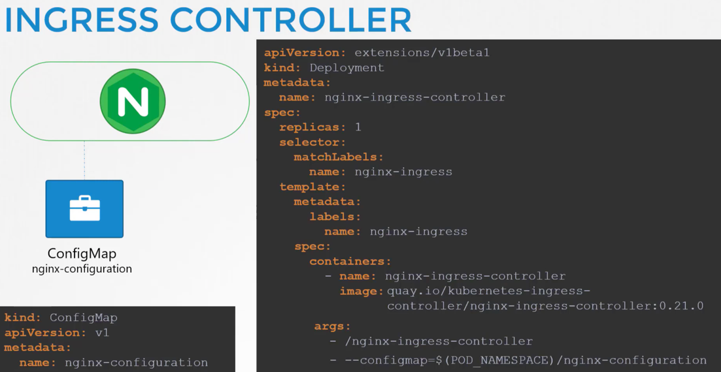

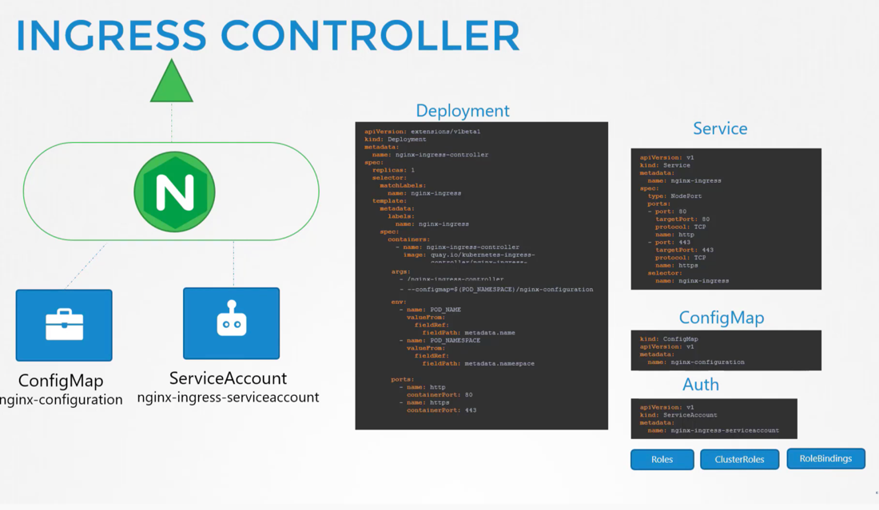

**Use Kubeadm for on-prem**

**GKE for GCP**

**Kops for AWS**

**Azure Kubernetes Service(AKS) for Azure**

**Storage**

* **High Performance - SSD Backed Storage**
* **Multiple Concurrent connections - Network based storage**
* **Persistent shared volumes for shared access across multiple PODs**
* **Label nodes with specific desk types**
* **Use Node Selectors to assign applications to nodes with specific disk**

**Nodes:**

* **Virtual or Physical Machines**
* **Minimum of 4 Node Cluster (size based on workload)**
* **Master vs Worker Nodes**
* **Linux X86_64 Architecture**

* **Master nodes can host workloads**
* **Best practice is to not host workloads on Master nodes (as a best practice is to recommended to dedicate master nodes for control plane only)**
* **Deployment tools like kubeadm prevent workload from being hosted on master nodes by adding a tent on the master node**

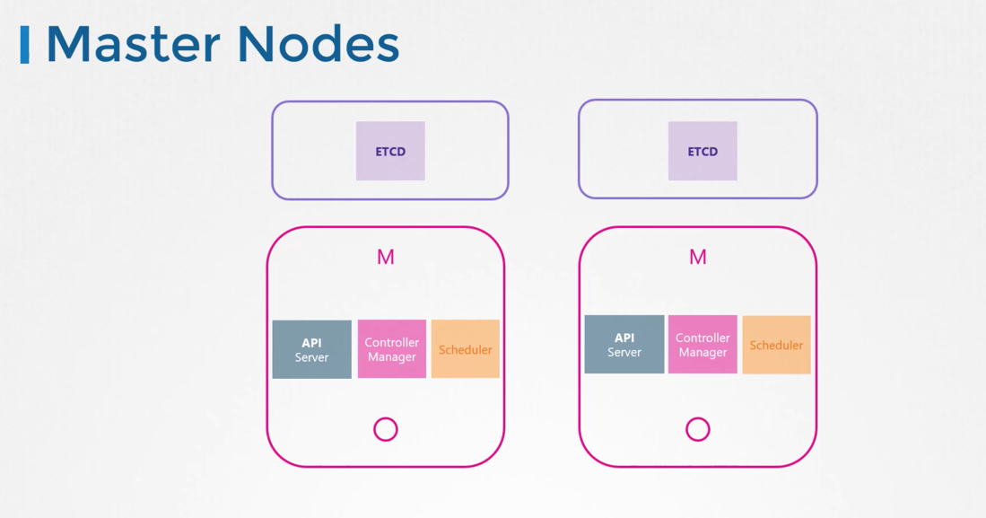

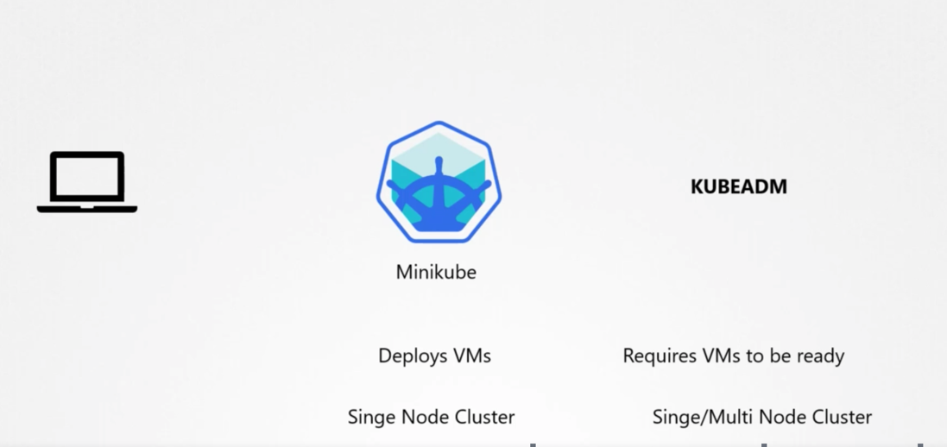

**OpenShift : open source container application platform and is build on top of kubernetes. It provides an set of additional tools and nice GUI to create and manage kubernetes constains easily integrate with CI/CD pipelines**

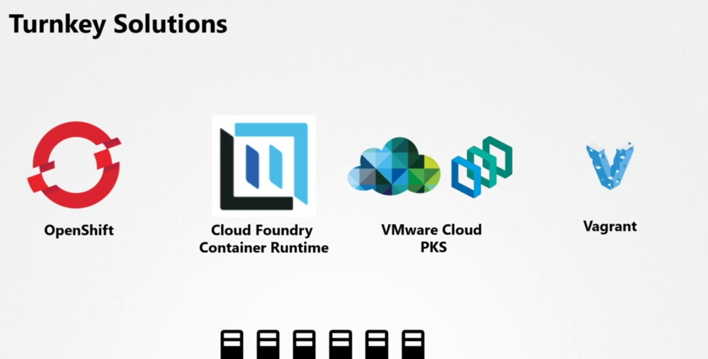

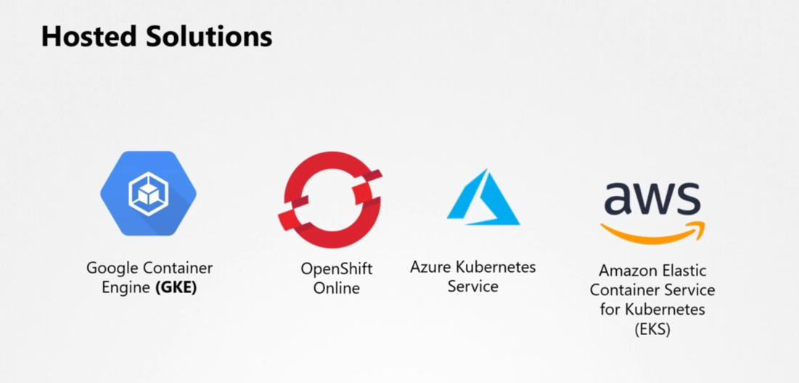

**Configuring High Availablity**

**Api server listen at port : 6443. and this is configured at kube config file**

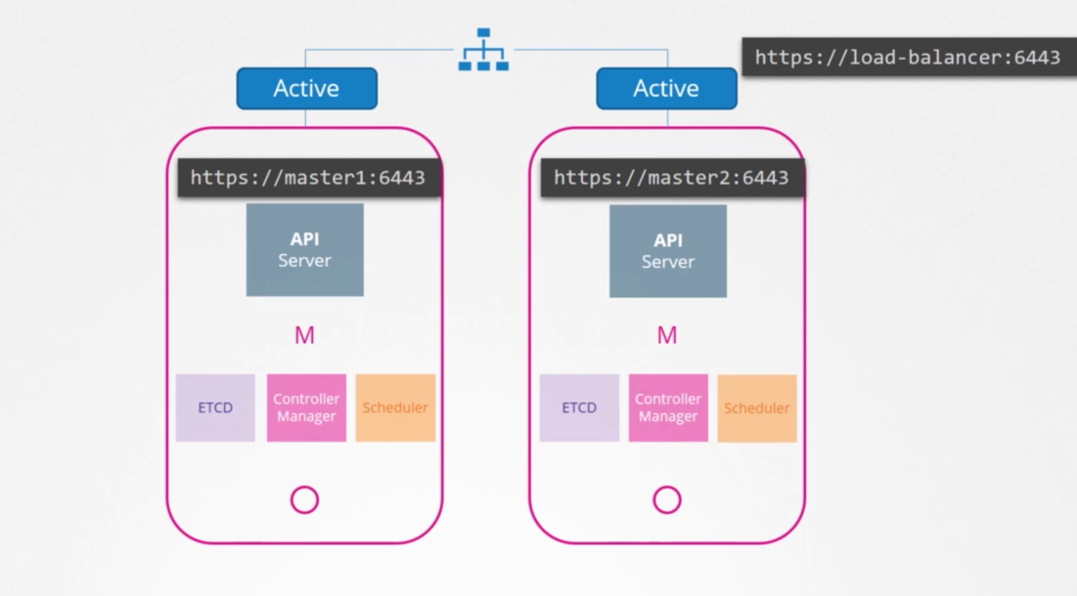

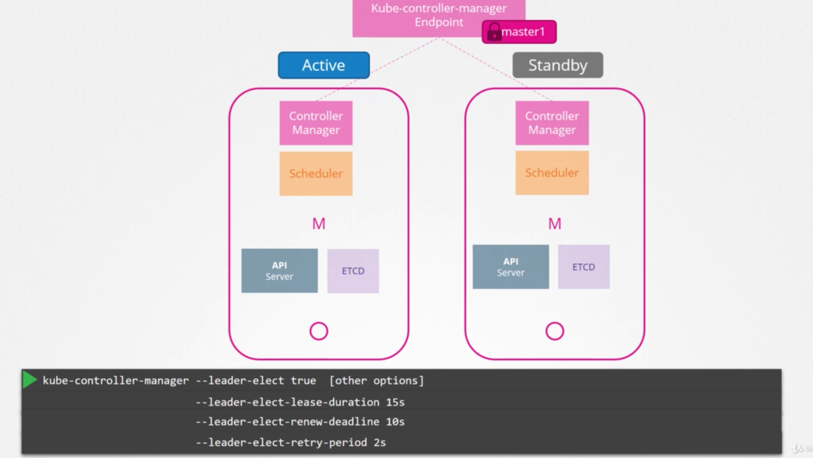

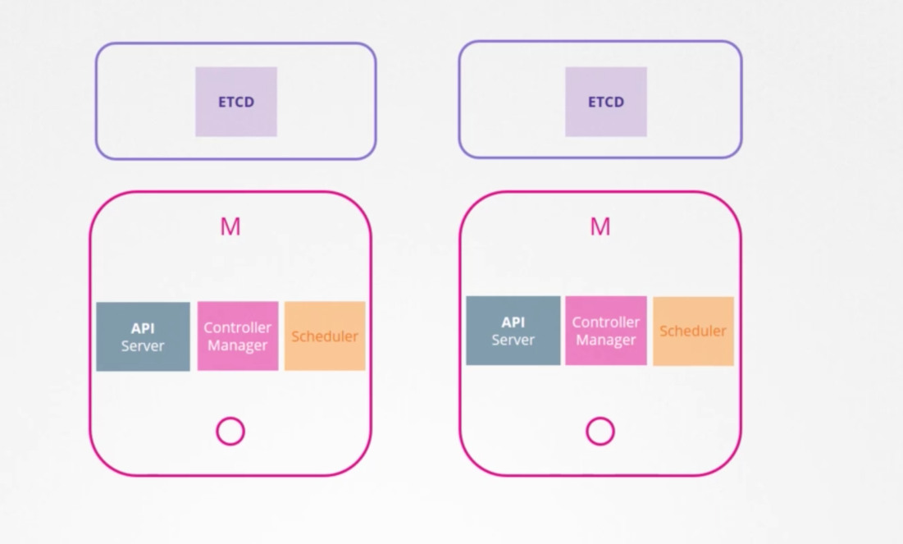

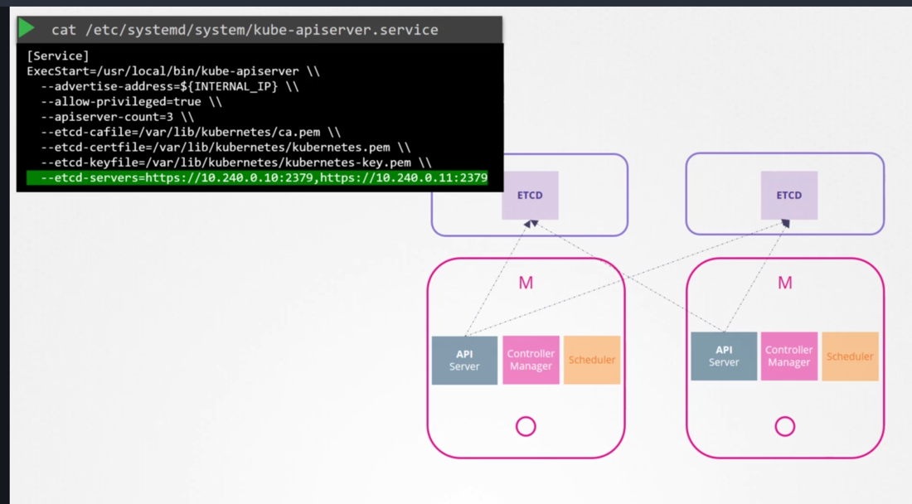

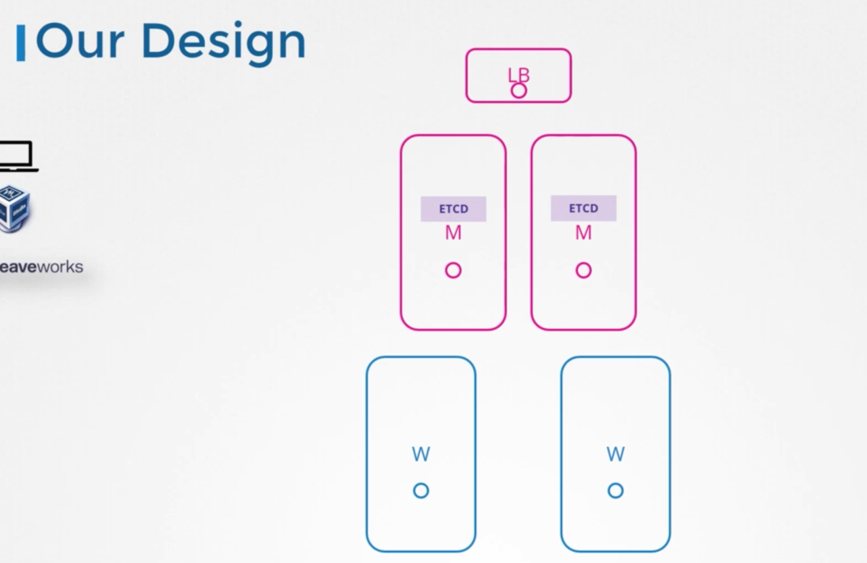

**ETCD in High availability : default port (2379)**

**ETD is a distributed reliable key-value store that is Simple,Secure and Fast**

**Leader Election - RAFT Algorithm**

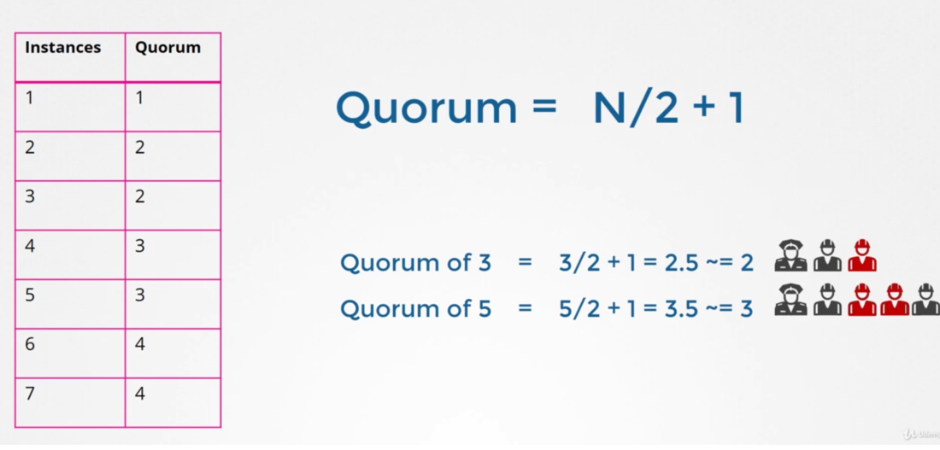

Install ETCD

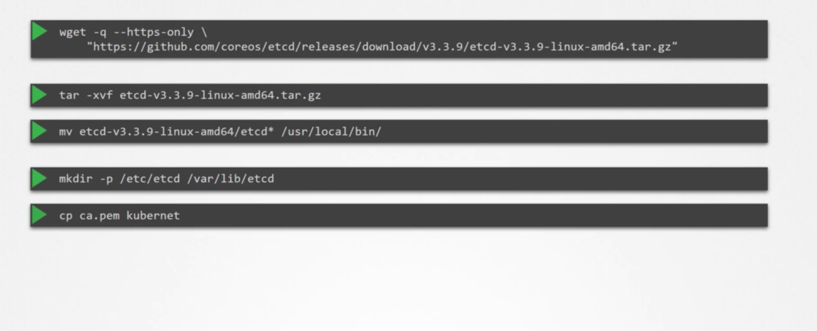

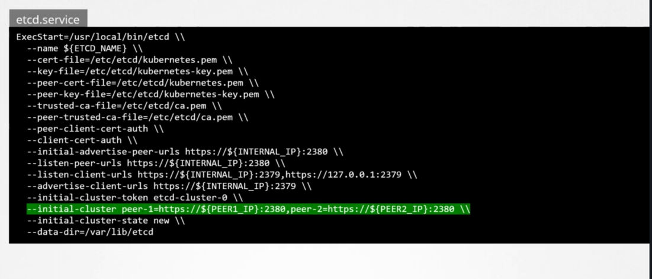

**To store and retrieve data**

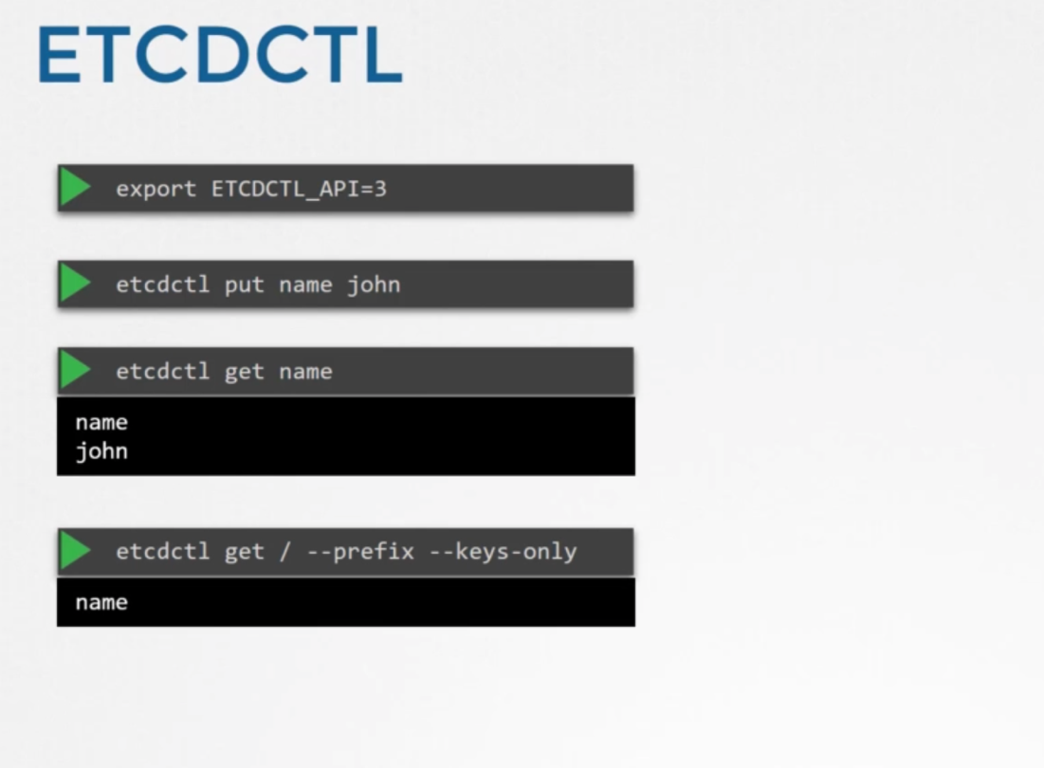

**Setup - kubeadm**

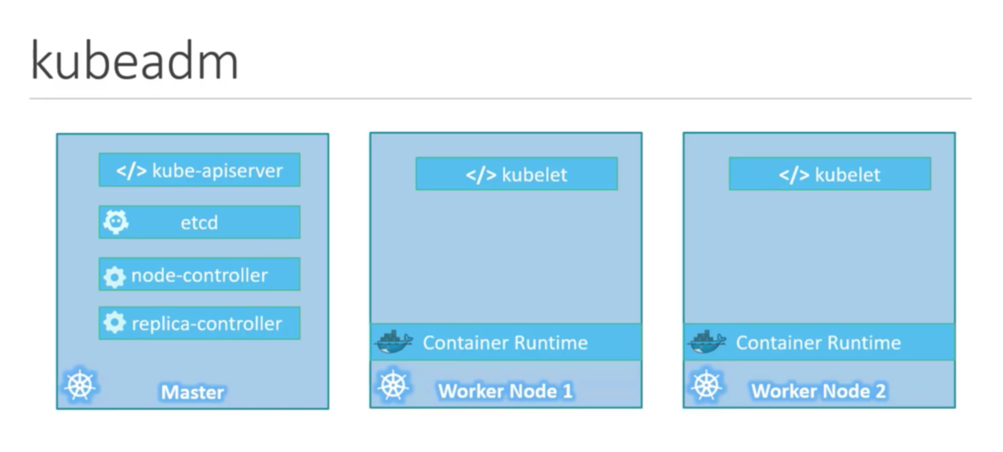

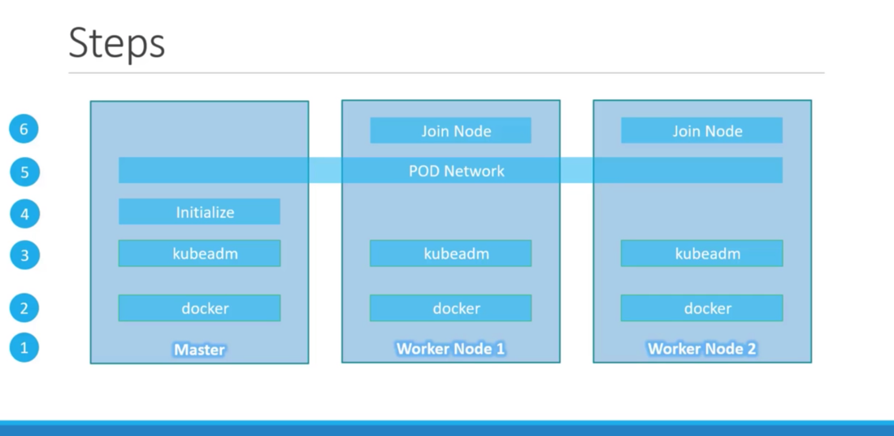

**Weave Net**

**To install cluster component**

* **Kubeadm init --podnetwork-cidr 10.244.0.0/16 --apiserver-advertise-address=192.168.56.2**

**Copying admin.conf into .kube/config**

**Sudo cp -i/etc/kubernetes/admin.conf $HOME/.kube/config**

**Deploe pod network to join worker nodes**

**Kubeadm join**

**Troubleshoot**

**Application Failures:**

**Two tier application : web server and database server**

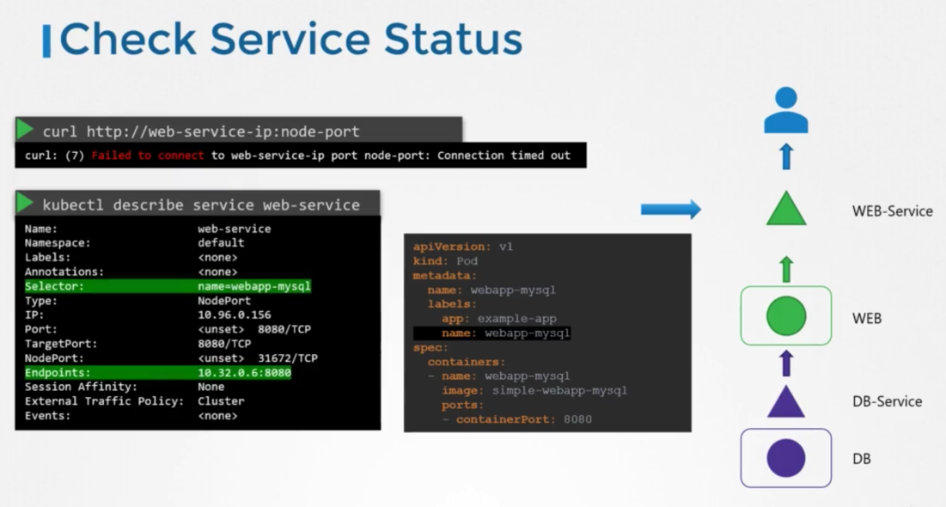

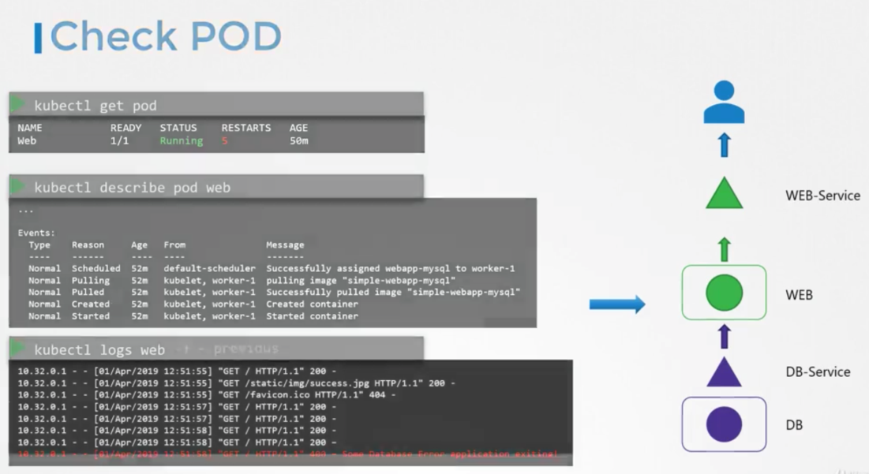

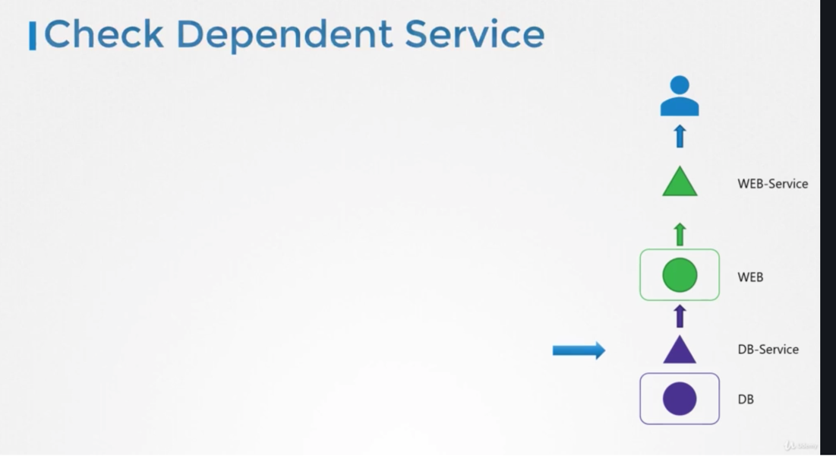

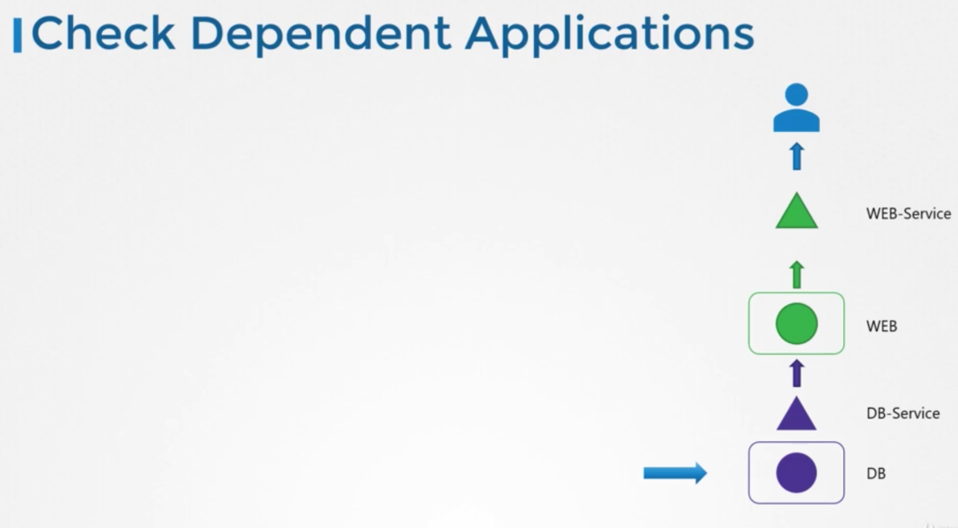

**Control Plane Failure:**

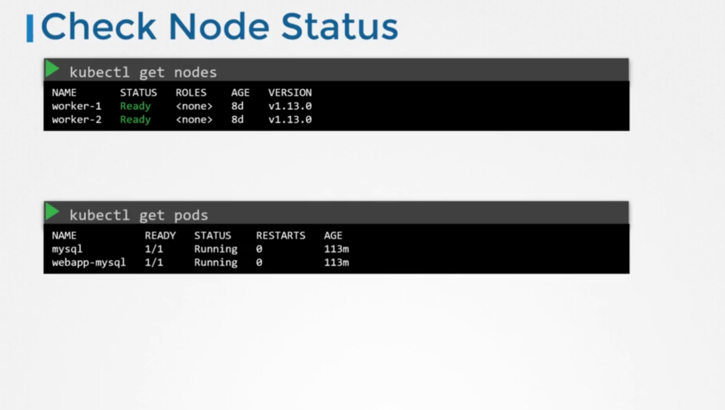

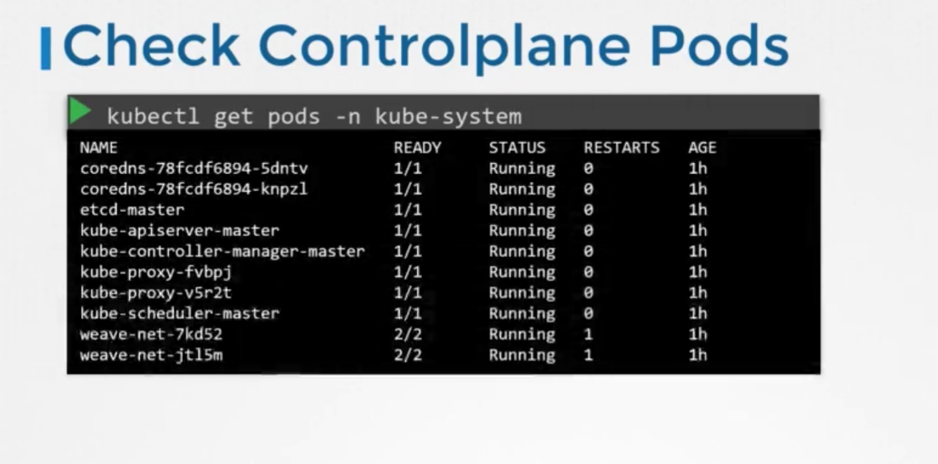

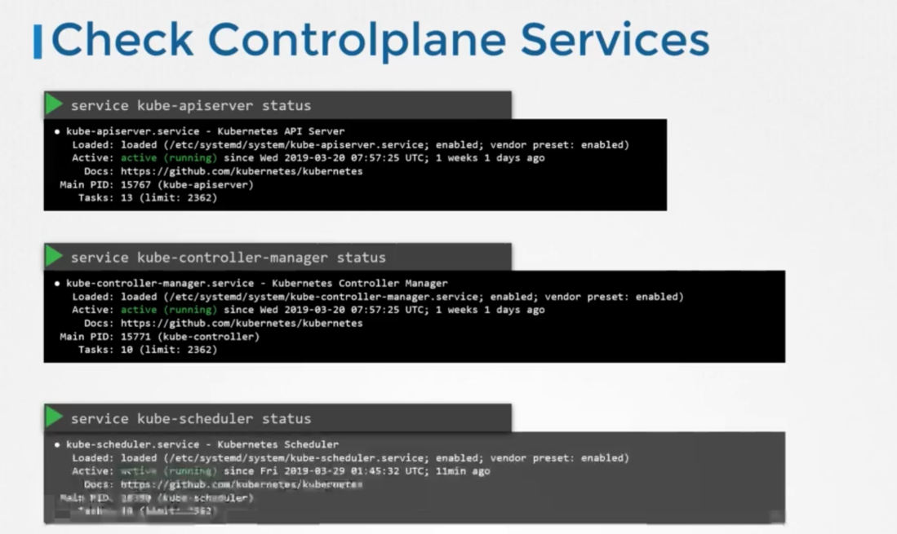

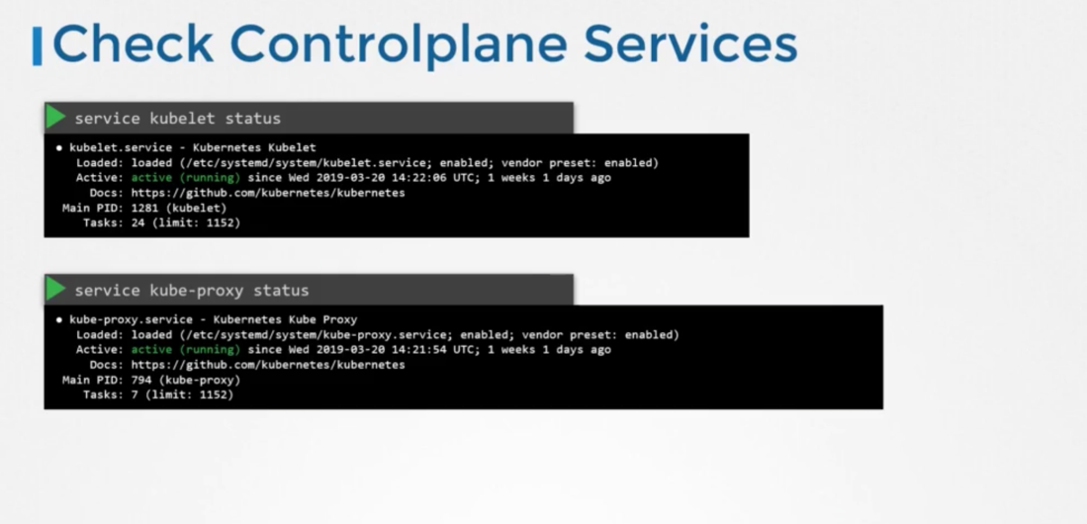

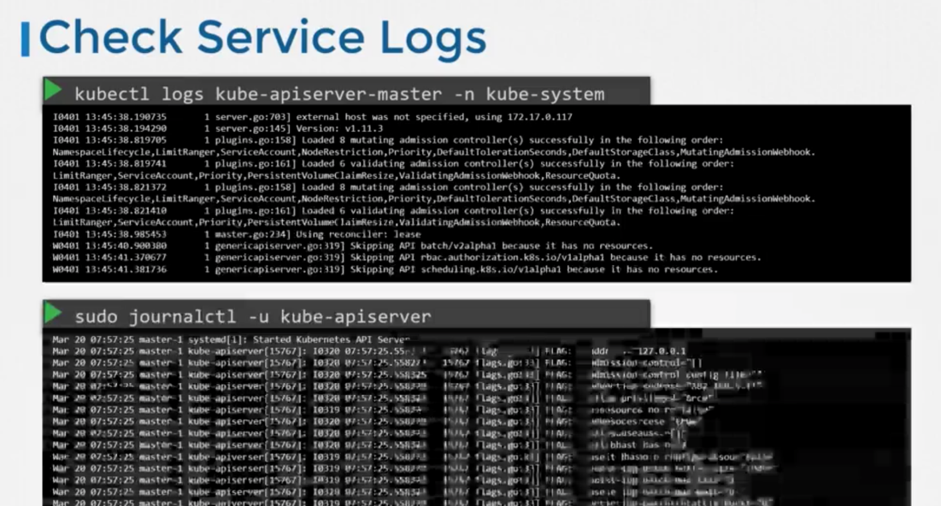

WorkNode Failure:

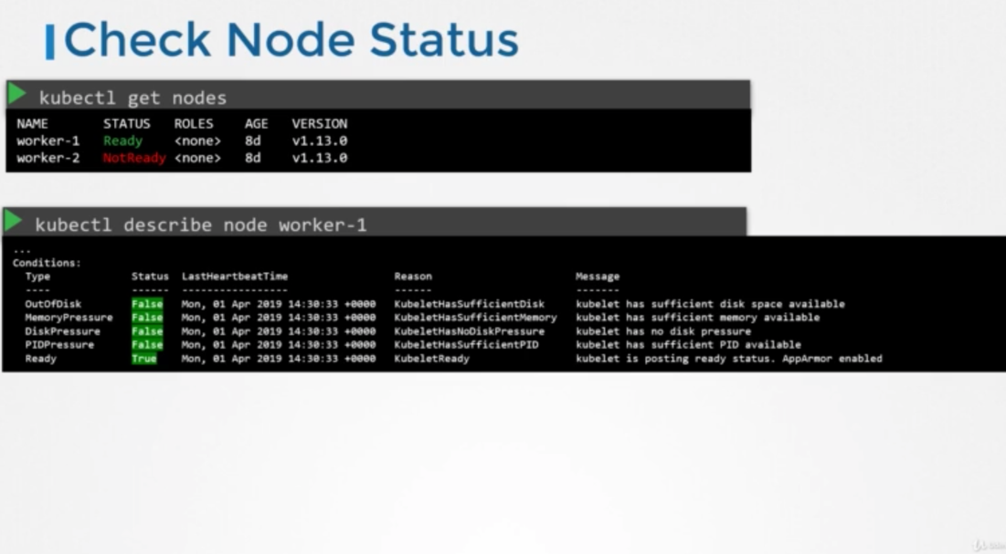

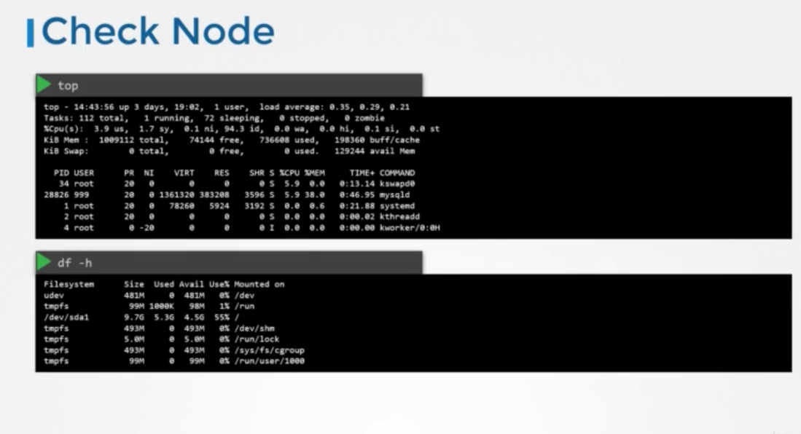

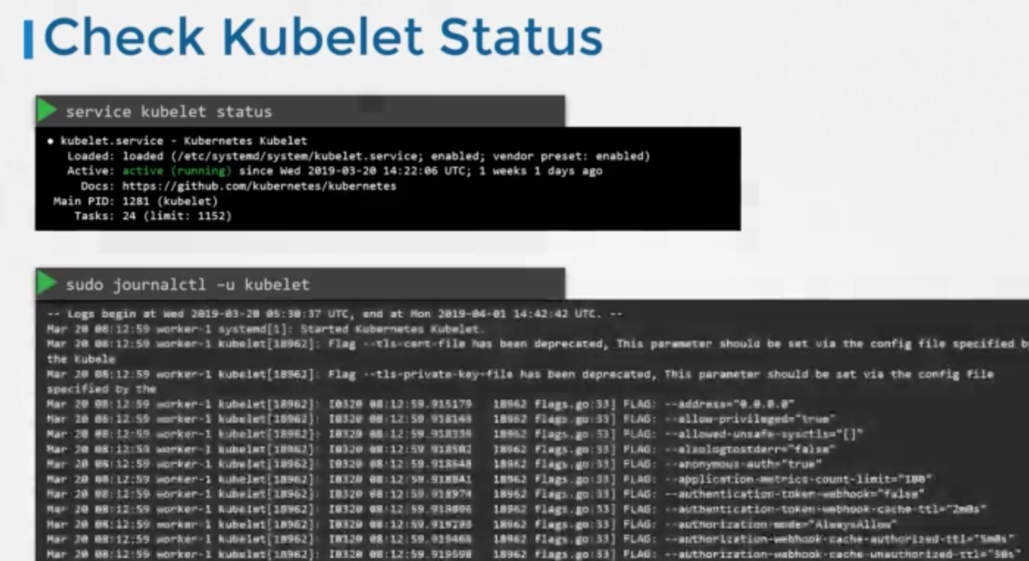

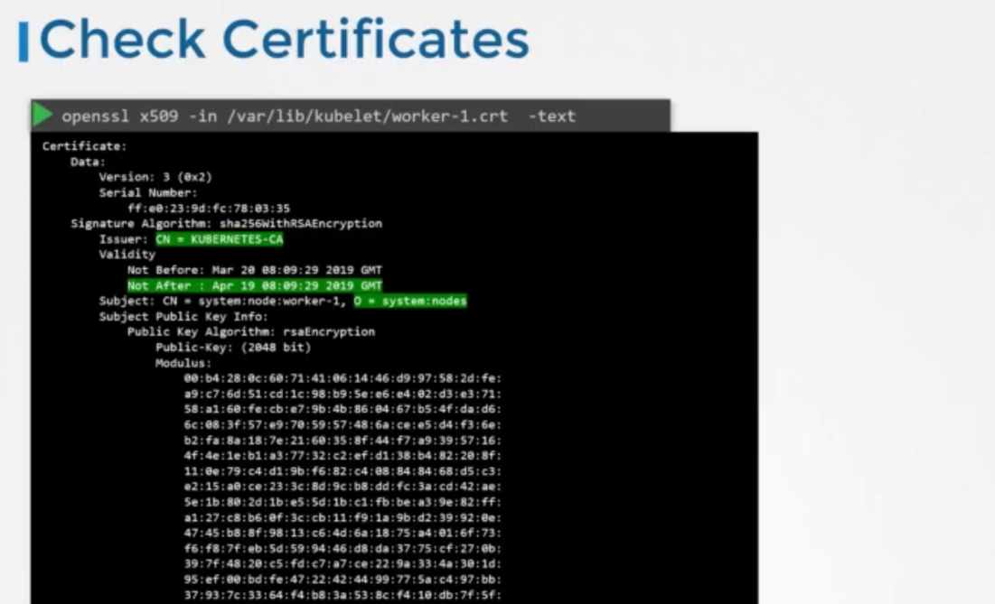

Network Troubleshooting:

**Network Plugin in kubernetes**

**--------------------**

Kubernetes uses CNI plugins to setup network. The kubelet is responsible for executing plugins as we mention the following parameters in kubelet configuration.

***- cni-bin-dir*:**   *Kubelet probes this directory for plugins on startup*

***- network-plugin:*** *The network plugin to use from cni-bin-dir. It must match the name reported by a plugin probed from the plugin directory.*

*There are several plugins available and these are some.*

**1. Weave Net:**

  These is the only plugin mentioned in the kubernetes documentation. To install,

kubectl apply -f "[https://cloud.weave.works/k8s/net?k8s-version=$(kubectl version | base64 | tr -d '\n')](https://cloud.weave.works/k8s/net?k8s-version=$(kubectl%20version%20|%20base64%20|%20tr%20-d%20'\n'))"

You can find this in following documentation :

[*https://kubernetes.io/docs/setup/production-environment/tools/kubeadm/high-availability/*](https://kubernetes.io/docs/setup/production-environment/tools/kubeadm/high-availability/)

**2. Flannel :**

   To install,

  kubectl apply -f               <https://raw.githubusercontent.com/coreos/flannel/2140ac876ef134e0ed5af15c65e414cf26827915/Documentation/kube-flannel.yml>

*Note: As of now flannel does not support kubernetes network policies.*

**3. Calico :**

   To install,

   curl <https://docs.projectcalico.org/manifests/calico.yaml> -O

*Apply the manifest using the following command.*

      kubectl apply -f calico.yaml

   Calico is said to have most advanced cni network plugin.

In CKA and CKAD exam, you won't be asked to install the cni plugin. But if asked you will be provided with the exact url to install it. If not, you can install weave net from the documentation

<https://kubernetes.io/docs/setup/production-environment/tools/kubeadm/high-availability/>

*Note: If there are multiple CNI configuration files in the directory, the kubelet uses the configuration file that comes first by name in lexicographic order.*

**DNS in Kubernetes**

**-----------------**

Kubernetes uses **CoreDNS**. **CoreDNS** is a flexible, extensible DNS server that can serve as the Kubernetes cluster DNS.

**Memory and Pods**

In large scale Kubernetes clusters, CoreDNS's memory usage is predominantly affected by the number of Pods and Services in the cluster. Other factors include the size of the filled DNS answer cache, and the rate of queries received (QPS) per CoreDNS instance.

Kubernetes resources for **coreDNS**are:

1. *a service account named****coredns****,*
2. *cluster-roles named****coredns****and****kube-dns***
3. *clusterrolebindings named****coredns****and****kube-dns****,*
4. *a deployment named****coredns****,*
5. *a configmap named****coredns****and a*
6. *service named****kube-dns****.*

While analyzing the coreDNS deployment you can see that the the ***Corefile plugin*** consists of important configuration which is defined as a ***configmap***.

Port **53** is used for for *DNS resolution*.

1. kubernetes cluster.local in-addr.arpa ip6.arpa {
2. pods insecure
3. fallthrough in-addr.arpa ip6.arpa
4. ttl 30
5. }

This is the backend to k8s for *cluster.local and reverse domains*.

proxy . /etc/resolv.conf

Forward out of cluster domains directly to right *authoritative DNS server*.

Troubleshooting issues related to coreDNS

1. If you find **CoreDNS** pods in pending state first check network plugin is installed.

2. coredns pods have **CrashLoopBackOff or Error state**

If you have nodes that are running SELinux with an older version of Docker you might experience a scenario where the coredns pods are not starting. To solve that you can try one of the following options:

a)Upgrade to a newer version of Docker.

b)Disable **SELinux.**

c)Modify the coredns deployment to set **allowPrivilegeEscalation** to *true*:

1. kubectl -n kube-system get deployment coredns -o yaml | \
2. sed 's/allowPrivilegeEscalation: false/allowPrivilegeEscalation: true/g' | \
3. kubectl apply -f -

d)Another cause for **CoreDNS**to have CrashLoopBackOff is when a **CoreDNS** Pod deployed in Kubernetes detects a loop.

  There are many ways to work around this issue, some are listed here:

* Add the following to your kubelet config yaml: ***resolvConf: <path-to-your-real-resolv-conf-file>*** This flag tells ***kubelet*** to pass an alternate ***resolv.conf*** to Pods. For systems using**systemd-resolved**, ***/run/systemd/resolve/resolv.conf*** is typically the location of the ***"real" resolv.conf***, although this can be different depending on your distribution.
* Disable the local DNS cache on host nodes, and restore ***/etc/resolv.conf*** to the original.
* A quick fix is to edit your **Corefile**, replacing forward ***. /etc/resolv.conf*** with the IP address of your upstream DNS, for example forward **. 8.8.8.8**. But this only fixes the issue for **CoreDNS**, ***kubelet*** will continue to forward the invalid ***resolv.conf*** to all default dnsPolicy Pods, leaving them unable to resolve DNS.

3. If **CoreDNS** pods and the**kube-dns** service is working fine, check the **kube-dns** service has valid ***endpoints***.

*kubectl -n kube-system get ep kube-dns*

If there are no endpoints for the service, inspect the service and make sure it uses the correct selectors and ports.

**Kube-Proxy**

**---------**

**kube-proxy**is a network proxy that runs on each node in the cluster. **kube-proxy**maintains *network rules on nodes*. These network rules allow network communication to the Pods from network sessions inside or outside of the cluster.

In a cluster configured with **kubeadm**, you can find **kube-proxy** as a ***daemonset***.

**kubeproxy** is responsible for watching *services and endpoint associated with each service*. When the client is going to connect to the service using the *virtual IP* the**kubeproxy**is responsible for *sending traffic to actual pods*.

If you run a kubectl describe ds kube-proxy -n kube-system you can see that the**kube-proxy** binary runs with following command inside the kube-proxy container.

1. Command:
2. /usr/local/bin/kube-proxy
3. --config=/var/lib/kube-proxy/config.conf
4. --hostname-override=$(NODE_NAME)

    So it fetches the configuration from a configuration file ie, ***/var/lib/kube-proxy/config.conf***and we can override the hostname with the node name of at which the pod is running.

  In the config file we define the **clusterCIDR, kubeproxy mode, ipvs, iptables, bindaddress, kube-config** etc.

Troubleshooting issues related to kube-proxy

1. Check **kube-proxy** pod in the **kube-system** namespace is running.

2. Check **kube-proxy**logs.

3. Check **configmap** is correctly defined and the config file for running **kube-proxy**binary is correct.

4. **kube-config** is defined in the **config map**.

5. check **kube-proxy** is *running* inside the container

1. # netstat -plan | grep kube-proxy
2. tcp 0 0 0.0.0.0:30081 0.0.0.0:* LISTEN 1/kube-proxy
3. tcp 0 0 127.0.0.1:10249 0.0.0.0:* LISTEN 1/kube-proxy
4. tcp 0 0 172.17.0.12:33706 172.17.0.12:6443 ESTABLISHED 1/kube-proxy
5. tcp6 0 0 :::10256 :::*

kubectl get nodes -o wide

**JSON PATH in Kubectl**

kubectl get nodes -o json

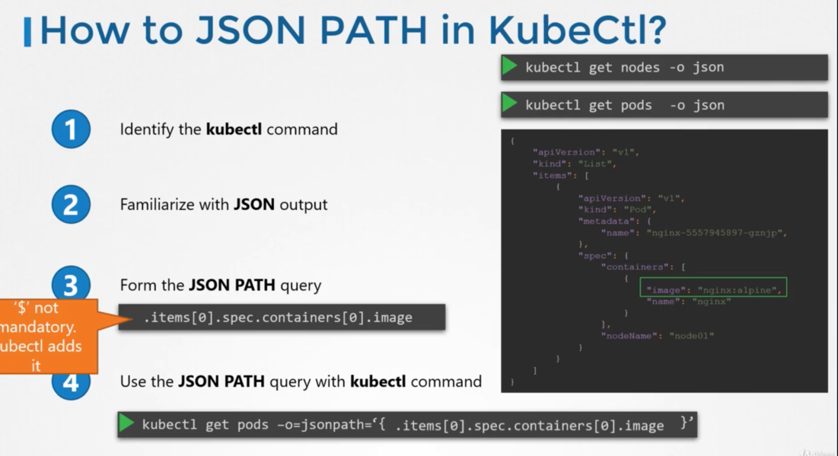

json path query evaluator - jsonpath.com

